# CS 255 Business Requirements Document

Complete this template by replacing the bracketed text with the relevant information.

This template lays out all the different sections that you need to complete for Project One. Each section has guiding questions to prompt your thinking. These questions are meant to guide your initial responses to each area. You are encouraged to go beyond these questions using what you have learned in your readings. You will need to continually reference the interview transcript as you work to make sure that you are addressing your client’s needs. There is no required length for the final document. Instead, the goal is to complete each section based on your client’s needs.

**Tip:** You should respond in a bulleted list for each section. This will make your thoughts easier to reference when you move into the design phase for Project Two. One starter bullet has been provided for you in each section, but you will need to add more.

## System Components and Design

### Purpose

*What is the purpose of this project? Who is the client and what do they want their system to be able to do?*

* The purpose of this project is to assist our client, DriverPass, with their goal of creating a system designed to assist drivers. The owner of DriverPass, Liam, hopes that this new system will aid drivers in their test taking and driving abilities.

### System Background

*What does DriverPass want the system to do? What is the problem they want to fix? What are the different components needed for this system?*

* DriverPass would like this new system to be cable of providing online classes, practice tests, as well as scheduling driving lessons.
* This system will be designed to fix the lack of efficient driver training that currently exists, assisting new drivers in passing their driving tests at the DMV.
* System needs to include:
  + Online classes and practice tests
  + The ability to reserve driving lessons
  + User account management that allows different roles for users
  + Security features to protect sensitive data
  + Integration with the DMV to allow for updates to test and class materials
  + Report downloading for offline access

### Objectives and Goals

*What should this system be able to do when it is completed? What measurable tasks need to be included in the system design to achieve this?*

* Creating a system that meets the client’s vision will require that the system contains the following capabilities:
  + Secure account registration
  + Online classes and practice tests
  + Reservation system for driving lessons that allows editing and cancellations
  + User roles that allow varying levels of access
  + Ability to reset passwords
  + Ability to select one of three instruction packages
  + Tracking of reservation activities for accountability
  + DMV integration for updates on study materials and tests
  + Tracking of practice test progress displayed in a user-friendly interface
  + System designed to run on the web and over the cloud allowing access from any internet connected device
  + Downloadable reports
  + Ability for admin to disable packages

## Requirements

### Nonfunctional Requirements

*In this section, you will detail the different nonfunctional requirements for the DriverPass system. You will need to think about the different things that the system needs to function properly.*

#### Performance Requirements

*What environments (web-based, application, etc.) does this system need to run in? How fast should the system run? How often should the system be updated?*

* The client requests that the system be web-based, preferably utilizing the cloud.
* The system should transition as seamlessly as possible between content, offering a user-friendly navigation experience.
* The system should update any time there is a change in rules, policies, or sample questions from the DMV.
* System updates should also be applied on an incremental basis to add new content as well as improve system functionality and fix errors in the system as they are discovered.

#### Platform Constraints

*What platforms (Windows, Unix, etc.) should the system run on? Does the back end require any tools, such as a database, to support this application?*

* The system will be web-based and should run on all mainstream browsers, regardless of the platform, including Chrome, Microsoft Edge, Firefox, and Safari.
* The back end will require a database to store information about the user, as well as transactional data, course data, and driver info.

#### Accuracy and Precision

*How will you distinguish between different users?* *Is the input case-sensitive? When should the system inform the admin of a problem?*

* Users of the system will be required to log in using case-sensitive passwords and usernames.
* Users will be assigned a role based on access level, which will define what system resources they can access.
* Repeated incorrect password attempts will result in an account lock. This lock will require identity verification, through email or text message, to be lifted.
* The system will send a notification to the admin when problems arise, such as account locks or other system errors.

#### Adaptability

*Can you make changes to the user (add/remove/modify) without changing code? How will the system adapt to platform updates? What type of access does the IT admin need?*

* Changes to user accounts will be possible without code modification.
* Platform updates will be tested before being moved to live production.
* Updates will be incremental to ensure that any resulting issues on the live server are minimal and easy to fix.
* IT admins will have full access to system resources.

#### Security

*What is required for the user to log in? How can you secure the connection or the data exchange between the client and the server? What should happen to the account if there is a “brute force” hacking attempt? What happens if the user forgets their password?*

* Log ins will be necessitated through the use of a password and username combination; 2FA will be suggested, but not required.
* In order to prevent “brute force” hacking attempts, after five failed log in attempts, accounts will be locked requiring password reset.
* Password reset will be possible through email, text, or other 2FA methods.
* HTTPS will be used to provide a secure connection between the user and the system.
* Cloud provider will have built in security measures as customer wishes to not have to deal with backup and security.
* Administrators will have the ability to block access to employees who have been terminated.

### Functional Requirements

*Using the information from the scenario, think about the different functions the system needs to provide. Each of your bullets should start with “The system shall . . .” For example, one functional requirement might be, “The system shall validate user credentials when logging in.”*

* The system shall validate user credentials when logging in.
* The system shall differentiate between different types of users including students, instructors, and administrators allowing each type of user different permissions.
* The system shall allow new users to create accounts when supplied with proper registration info.
* The system shall allow users to update their profile and add information to their account.
* The system shall provide users with up-to-date information from the DMV regarding rules and regulations.
* The system shall allow users to purchase one of three packages, each offering different benefits at different price points.
* The system shall offer users who have purchased package three access to study materials and practice tests.
* The system shall let users schedule driving appointments as well as in-person lessons.
* The system shall provide users with information about their driver and the car that they will be using for their lessons, as well as a picture of both.
* The system shall track user progress in their courses and tests and shall display this information to users in an easy-to-understand fashion.
* The system shall create reports regarding reservations and other details for administrators to be able to track issues.
* The system shall provide notifications to users regarding important updates and information as well as reservation details and reminders for scheduling.
* The system shall allow administrators to update course information as well as disable the packages available for purchase.

### User Interface

*What are the needs of the interface? Who are the different users for this interface? What will each user need to be able to do through the interface? How will the user interact with the interface (mobile, browser, etc.)?*

* The system will be accessed through a web browser. The system will contain various different pages for access to the full functionality of the system. These pages will include:
  + Homepage-
    - Shows online test progress, user personal info, driver notes (including lesson information), driver and student photo, as well as potential special needs.
  + User account registration page
  + User profile page (access for profile editing)
  + Course material and test page
  + Driver lesson reservation page
  + DriverPass package store
  + DriverPass contact information page
  + Administrative page (admin access only)
* Users will consist of students, instructors, the DriverPass secretary, DriverPass IT, and the owner of DriverPass. All new users will be given base privileges as a student user. These privileges will allow users to access profile details, course materials (if they have purchased package three), the package store, reservation page, and the DriverPass contact page. Accounts are able to be promoted to different levels of access by the IT department or the DriverPass owner. Instructors will have the ability to see additional information about upcoming appointments with students. The DriverPass secretary will have access that allows them to schedule appointments for student accounts. Finally, the DriverPass IT and DriverPass owner will have full access to the system and will be able to view the administrative page as well as have access to reports and other functionality that normal users are unable to access.

### Assumptions

*What things were not specifically addressed in your design above? What assumptions are you making in your design about the users or the technology they have?*

* Users have a basic understanding of computer functionality in order to be able to navigate to the website and utilize its features.
* Users have a stabile internet connection.
* DMV guidelines and regulations are available for DriverPass use and are kept current.
* This design will be within the budget of DriverPass.

### Limitations

*Any system you build will naturally have limitations. What limitations do you see in your system design? What limitations do you have as far as resources, time, budget, or technology?*

* This system is limited by the requirement for power and internet access in order to function.
* A budget was not discussed, but it will certainly have an impact on the development process.
* The schedule created allows for a total of less than 4 months for development.
* The development team is small and, depending on time constraints, could require additional staff to meet deadlines.
* The DriverPass system relies on information from the DMV in order to be accurate in the material it provides. Thus, any issue with obtaining information from the DMV will limit the system’s accuracy in the content that it delivers.
* The system will not initially allow for package management, other than disabling the existing packages.
* The system will potentially not work on browsers or platforms that are not supported.
* The system design will only allow a certain number of concurrent users, and past that limit, the system will experience usability issues or potentially crash.

### Gantt Chart

*Please include a screenshot of the GANTT chart that you created with Lucidchart. Be sure to check that it meets the plan described by the characters in the interview.*

[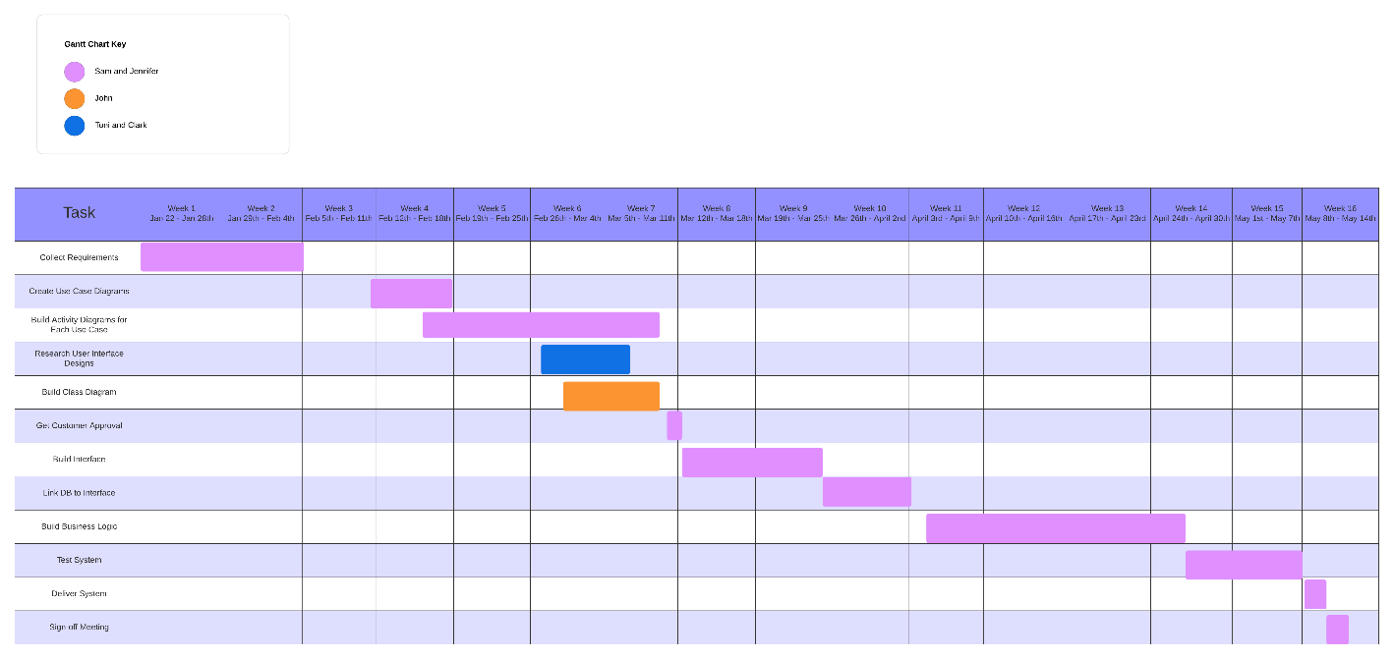](https://lucid.app/lucidchart/8e1f7f94-a4fd-4a3d-a529-f3030a443bab/edit?crop=content&page=0&signature=2318145785692e61b0ab68bd48312d81465b0c106b613352e1db1647c708cff5)